**Longest Sub-Array with Sum K**

[*https://practice.geeksforgeeks.org/problems/longest-sub-array-with-sum-k0809/1?utm_source=gfg&utm_medium=article&utm_campaign=bottom_sticky_on_article*](https://practice.geeksforgeeks.org/problems/longest-sub-array-with-sum-k0809/1?utm_source=gfg&utm_medium=article&utm_campaign=bottom_sticky_on_article)

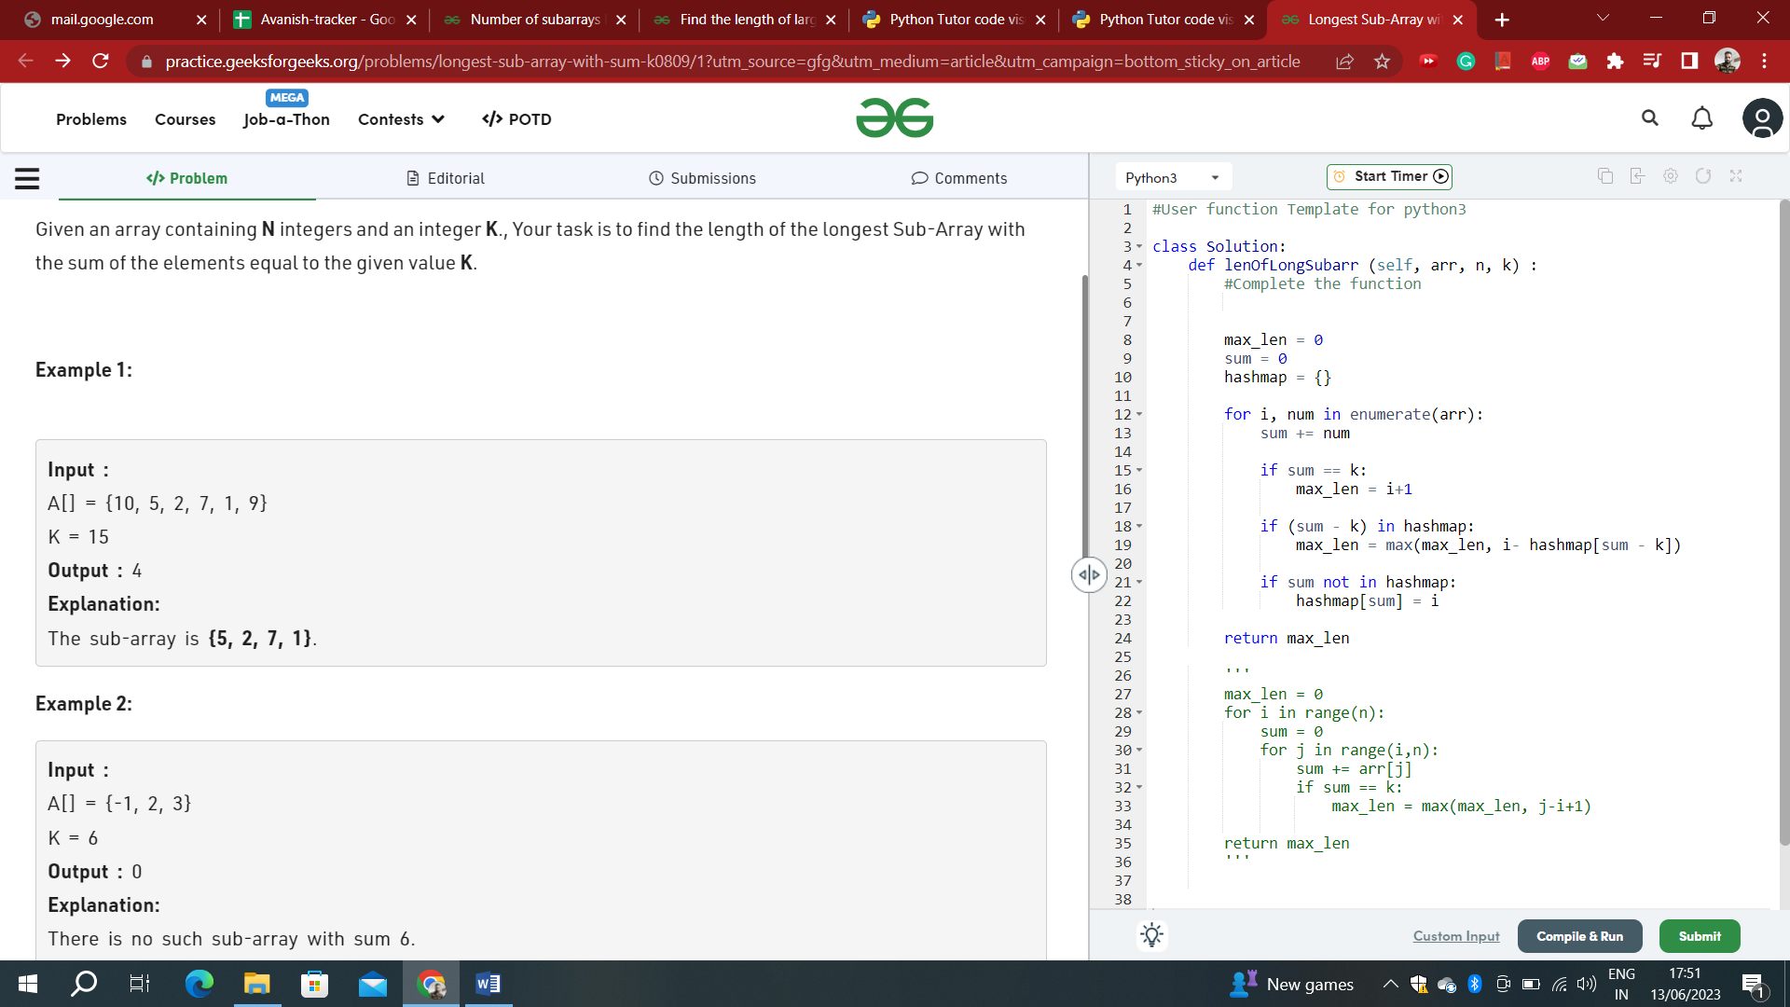

*class Solution:*

*def lenOfLongSubarr (self, arr, n, k) :*

*#Complete the function*

*max_len = 0*

*sum = 0*

*hashmap = {}*

*for i, num in enumerate(arr):*

*sum += num*

*if sum == k:*

*max_len = i+1*

*if (sum - k) in hashmap:*

*max_len = max(max_len, i- hashmap[sum - k])*

*if sum not in hashmap:*

*hashmap[sum] = i*

*return max_len*

*'''*

*max_len = 0*

*for i in range(n):*

*sum = 0*

*for j in range(i,n):*

*sum += arr[j]*

*if sum == k:*

*max_len = max(max_len, j-i+1)*

*return max_len*

*'''*